Sultan Uramaev  C++ Software Developer |  | 

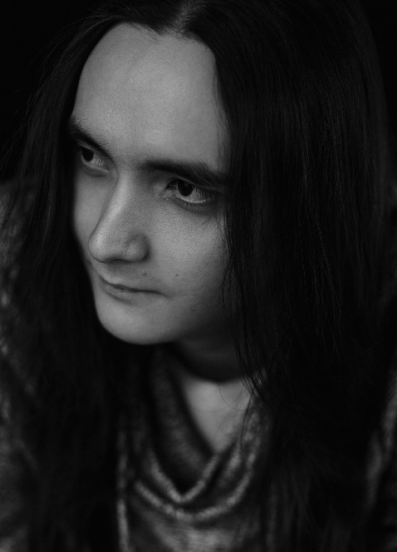  CONTACTS   xottab-duty@yandex.ru   t.me/xottab_duty  github.com/Xottab-DUTY  SKILLS  - C++  - Lua  - C# (beginner)  - Unreal Engine (beginner)  - UE Blueprints (or similar visual scripting tools, beginner)  TOOLS  - Visual Studio (2015, 2017, 2019, 2022)  - Visual Studio Code  - Version control systems: Git, Perforce, SVN  - Continuous Integration (AppVeyor, GitHub Actions)  LANGUAGE  Russian ••••• Native  English ••••• B2 Upper-Intermediate  Polish ••••• A2 Elementary  EDUCATION  Software-engineer in applied informatics  Tobolsk Pedagogical Institute | SUMMARY  2 years of commercial С++ programming experience, 6 years overall. Hands-on experience with various commercial game engines, including UE4, deep knowledge of the X-Ray game engine, used in the world-famous S.T.A.L.K.E.R. game series by GSC Game World.  My priority areas in the game engine are:  - сore  - low level, platform code (especially love porting to new platforms)  - renderer (partial knowledge of a renderer pipeline and a desire to be a renderer developer)  - AI (no experience, but there is a desire to learn)  - UI  Also, I love hunting and eliminating bugs. =) The deeper knowledge of the codebase, the more drive: solving easy bugs is a place for rest, tasks are being closed one by one and my heart swells while complex bugs almost always lead me to my professional grow.  During work my responsibilities were:  - Adding new features. (on all levels: game library, middleware, low level platform code)  - Debugging the codebase, catching bugs.  - Profiling, finding performance bottlenecks.  - Analysing the codebase using static analysers. (PVS-Studio, CppDepend, ReSharper, Visual Assist)  - Communicating with peers within the team.  - Different team sizes from 5 to 30 people.  - Keeping to the client’s code style, procedures, adopted C++11/C++14/C++17 standards on the project.  - Logging in Jira.  WORK CONDITIONS  No relocation from Russia (relocation within Russia may be considered).  Full remote work is preferred, but work from the local office is also possible (in this case Saint Petersburg, Moscow is preferred, if applicable).  WORK EXPERIENCE  SPERASOFT  November 2020 – July 2022  April 2022 – July 2022 Project: Injustice 2 Fighting video game developed by NetherRealm Studios and published by Warner Bros. Interactive Entertainment.  April 2022 – July 2022 Project: Mortal Kombat Mobile Fighting video game developed by NetherRealm Studios and published by Warner Bros. Interactive Entertainment.  November 2021 – March 2022 Project: Madden NFL 22 American football video game based on the National Football League (NFL), developed by EA Tiburon and published by Electronic Arts. - UI - Gameplay features - Bugfixes, optimization  February 2021 – October 2021 Project: Saints Row (2022) Action-adventure video game developed by Volition and published by Deep Silver. - Various UI elements and features  December 2020 – January 2021 Project: NDA* Internal project  SIDE PROJECTS, HOBBY, etc.  2015 – now Project: OpenXRay An open-source improvement of X-Ray game engine, used in the world-famous S.T.A.L.K.E.R. game series by GSC Game World. https://github.com/OpenXRay/xray-16 - Management of a 3–5-person team. - Tasks decomposition, distribution and tracking. - Porting game engine to Linux. - Getting rid of platform-specific code when possible or making wrappers around it. - Rewriting WinAPI code to SDL2. - Implementing OpenGL-renderer. - Porting shaders from HLSL to GLSL. - Shader cache support. (GL_ARB_get_program_binary) - Work on renderers: - Unifying DX9, DX10, DX11, OpenGL renderer frontends into one. - Extending backend with missing functionality which was implemented in the frontend directly. (see next item) - Removing direct GAPI calls from frontend. All calls should go through backend. - Original engine had three separate frontends, which had almost no differences between them (literally copy-paste) and were directly calling DirectX bypassing the backend... - Support for feature level 10 in DX11 renderer. This allowed us to easily unify DX10 and DX11 renderers and greatly reduce the amount of code we need to support. - Support for legacy DX9 shaders on DX11 renderer. (D3DCOMPILE_ENABLE_BACKWARDS_COMPATIBILITY) - This required modifying shader constants system, which required unique names for constants, while shader compiler produced constants with different types, but same names. - The engine has been extended to support two games: now it can be used to play both S.T.A.L.K.E.R.: Call of Pripyat and S.T.A.L.K.E.R.: Clear Sky. Support for S.T.A.L.K.E.R.: Shadow of Chernobyl is under way. - A lot of engine work on support for legacy game assets, including different behaviour of the file system, different binary formats, missing animations, different AI/UI/gameplay logic, etc. - Custom work-stealing task scheduler system with low overhead: ~700 CPU cycles when system is warm, 2000 when you need to wake up threads, ~7000 worst case. - Gamepad support. - Game was supporting keyboard and mouse only, in some places of the UI it even was hardcoded to specific keyboard/mouse keys, without the user ability to rebind it. - Detecting gamepad devices and handling input in the lower-level input subsystem. (using SDL2) - Extending game keybinding system to support binding game actions to gamepad buttons, sticks. - Processing input from gamepad in the higher-level gameplay systems as binded game actions. - Code optimizations and improvements, refactoring and modernizing using C++11, C++17, which ultimately increased overall stability and performance of the engine.

